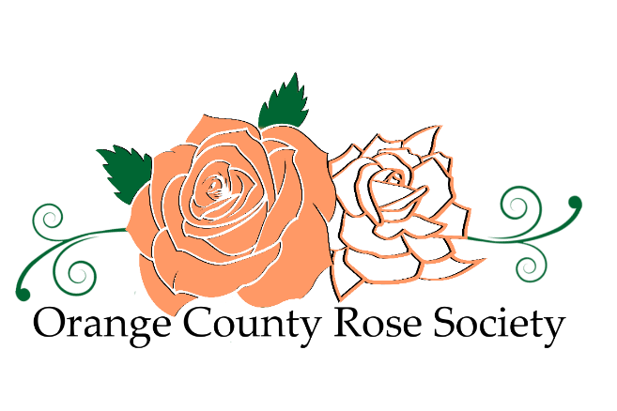
For 2026, the membership dues will be $25 per household
Newsletters are sent by email
Send the application and check payable to “OCRS” to:

Orange County Rose Society
P O Box 2143
Costa Mesa, CA 92628-2143

2026 Orange County Rose Society
Membership Application and Renewal Form
(Please print)

The OCRS also offers online payment for membership dues and renewals. Online payments can be made by credit card or PayPal. Checks may be sent to the P.O. Box listed above, and cash payments can be made at our monthly meetings.

Name(s): __________________________________________________

Address: _________________________________________________

City/State/Zip Code: ________________________________________

Telephone: ( ) _________________________

E-Mail: ___________________________________________________

Member of the American Rose Society? YES NO

What topic(s) would you like to see discussed at our meetings this year?

_________________________________________________________

